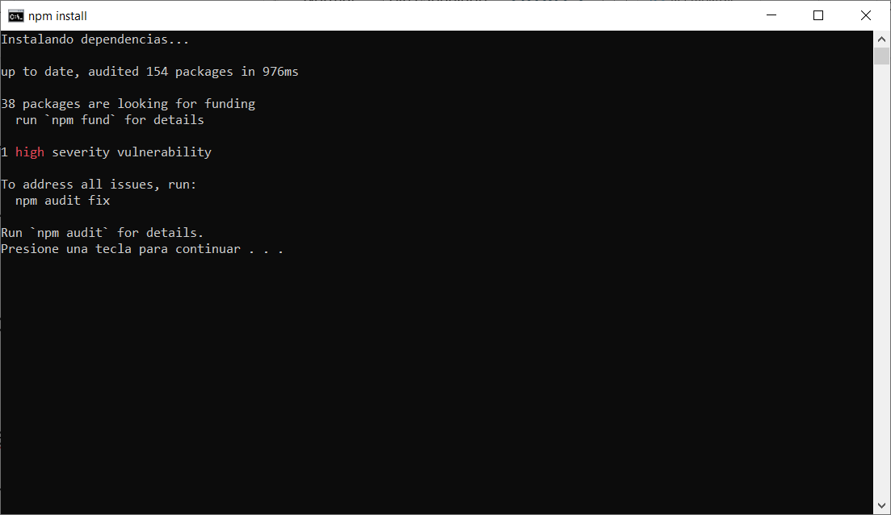

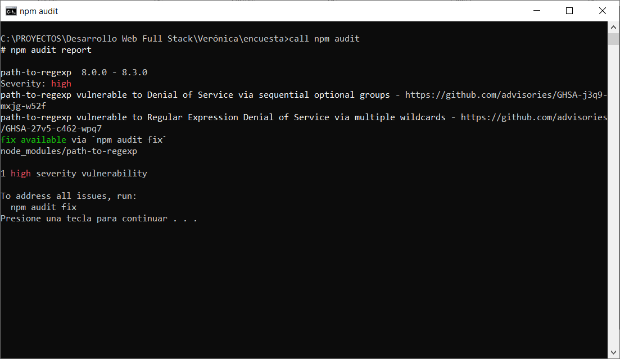

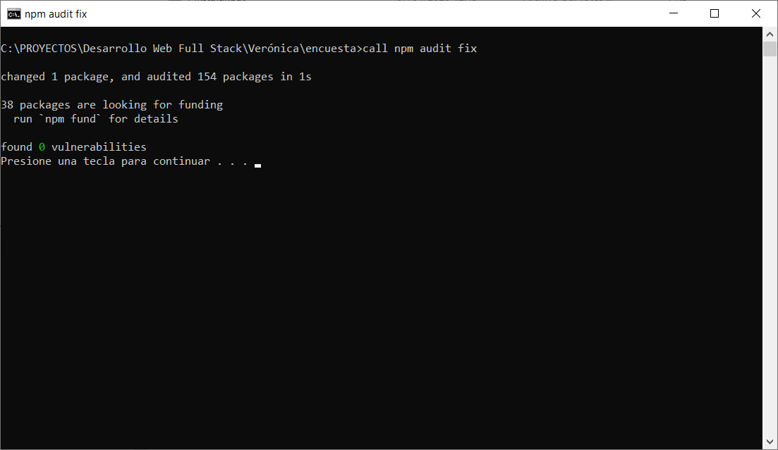
"dependencies": {
"cors": "^2.8.6",
"express": "^5.2.1",
"sqlite3": "^6.0.1"

Instalando dependencias...

up to date, audited 154 packages in 976ms

38 packages are looking for funding
run `npm fund` for details

1 high severity vulnerability

To address all issues, run:
npm audit fix

Run `npm audit` for details.
Presione una tecla para continuar . . .

# npm audit report

path-to-regexp 8.0.0 - 8.3.0
Severity: high
path-to-regexp vulnerable to Denial of Service via sequential optional groups - https://github.com/advisories/GHSA-j3q9-mxjg-w52f
path-to-regexp vulnerable to Regular Expression Denial of Service via multiple wildcards - https://github.com/advisories/GHSA-27v5-c462-wpq7
fix available via `npm audit fix`
node_modules/path-to-regexp

1 high severity vulnerability

To address all issues, run:
npm audit fix
Presione una tecla para continuar . . .

